Ángeles Maqueira Yamasaki

Martín Fabbri García

Octavio Montestruque Bisso

Katerine Tapia Vila

University of Lima, Lima – Perú

**Weberhofer Quintana, Walter (1923-2002)**

[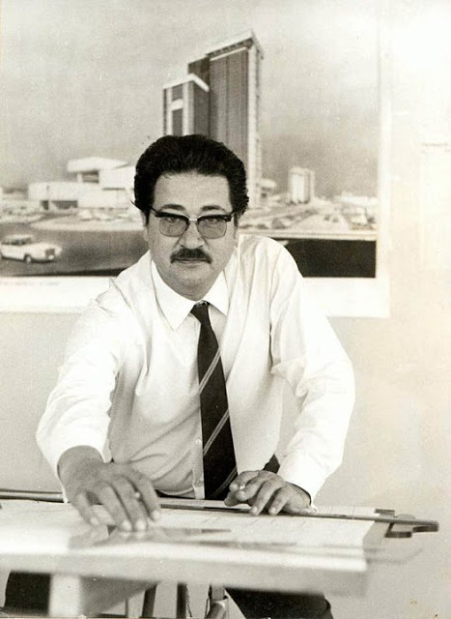](http://2.bp.blogspot.com/-OOmqPtLzV-I/UO4iNQdBPlI/AAAAAAAALYI/2oXLVu1b0j0/s1600/281478_118947728197592_4722939_n.jpg)

<http://laformamodernaenlatinoamerica.blogspot.com/2013/01/walter-weberhofer.html>

Weberhofer Walter was born in San Jeronimo de Tunari, in the province of Huancayo, department of Junín, on March 24, 1923. Son of Oswald Weberhofer (forester) and Dolores Quintana Pilts Gurt. Before graduating from Alfonso Ugarte School in 1940, he began his work as a draftsman. Achieving a position in 1942 at the Ministry of Development and Public Works. In 1946 he entered as a draftsman in the office of the peruvian architect Enrique Seoane. This first encounter with one of the great modern architects of Peru marked the itinerary of an intense search for a clean design and attention to details.

In 1947 he started studying architecture at the National University of Engineering (UNI). In this school he will get to know Mario Bianco[1] and Theodore Cron[2], both european architects which by then were disseminating the lines of modernity in the Faculty of Arts, Architecture and Urbanism of the National University of Engineering[3].

In 1948 he joins the office of Jose Alvarez Calderón. He graduated as an engineer-architect in 1951. In 1953 performed internships in Brazil and, since his return in 1956, he joined National University of Engineering as an assistant professor. In 1956 Walter Weberhofer in association with Jose Alvarez Calderon, built the Atlas Building[4]. Wich was a a high-rise building, inserted in the historic center of the city, in response to the guidelines of the Pilot Plan of 1949 for the city of Lima. The building consists of two large office volumes that emerge from the floor to contain in the basement, the commercial use.

With this building, its partnership with Jose Alvarez Calderon, ends. A year after that, he starts the association with Remigio Collantes, which would end in 1965. In this span of time he gets involved with the resort of Santa Maria del Mar, one of the resorts south of Lima:

“Weberhofer will be remembered, above all, for his work as the exclusive architect of Santa Maria del Mar, although his designing skills have always been reduced, by an environment that has always looked for the label of some international school, style, or teacher. Because if it is not Brazilian influence, their work is under the shadow of Japanese metabolism [[5]], or clear the aura of Richard Neutra and Paul Rudolph” [6] (Dede, 2011).

In 1970 he won the competition for the headquarters of Petro-Peru in association with Daniel Arana Rivers. This building is one of the most compelling landmarks of modernity, inserted also on the fast track known as the Expressway or Paseo de la Republica, built in 1967 during the municipal government of Luis Bedoya Reyes

Between 1973 and 1979, he worked as an inspector of Public Works and Land without building, in Santa Maria del Mar City Council, where he will do a lot of works of residential character. After his death, the City Council named the pier after him.

Many contemporary architects compare Weberhofer´s work with modern Brazilian architecture. The reason, evidently founded on his years of pre-professional practice in Brazil, is his apparent renunciation to orthogonality and constant use of movement in inner space. Others approach his work to the Zaha Hadid´s initial work, who engage with acute and obtuse angles. However, the tendency to use non-straight angles, seems to respond to the favorite displaying resource of modern architects: the perspective[7].

Walter Weberhofer had the discipline and obsession to record all his work. The Weberhofer File is one of the most complete archive in the history of modern peruvian architecture. His son, Heinz Weberhofer, who lives in Lima, still preserves it. Peruvian architect Hector Abarca, resident in Canada, is constantly feeding his facebook page[8] and other links[9] on the vast work of Walter Weberhofer.

Walter Weberhofer tuvo la disciplina y obsesión de registrar todo su trabajo. El archivo Weberhofer, es uno de los más completos de la arquitectura moderna del Perú. Su hijo Heinz Weberhofer, quien reside en Lima, aún lo conserva y el arquitecto peruano Héctor Abarca, residente en Canadá, alimenta constantemente una página de facebook y otros linkssobre la vasta obra de Walter Weberhofer.

**Work list:**

1956 Atlas Insurance Building, Historic Centrer, Lima (with José Álvarez Calderón)

1956 San Jorge School, Miraflores, Lima

1957 Tauro Cinema, Historic Centrer, Lima

1957 Esmeralda Yatch Club, Santa María del Mar, Lima

1957 Lercari House, Santa María del Mar, Lima

1957 Fernandini House, Santa María del Mar, Lima

1957 Las Sirenas Biulding, Santa María del Mar, Lima (with Remigio Collantes)

1958 Alvarez Calderon House, Santa María del Mar, Lima

1960 Pucusana Yatch Club, Pucusana, Lima

1965 Mines Faculty, UNI, Rímac, Lima (with Remigio Collantes)

1968 Pacifico Biulding, Miraflores, Lima (with José Álvarez Calderón)

1970 Weberhofer House, Córpac, Lima

1972 Gran Chimú Coliseum, Trujillo, Lima

1973 Petroperú Headquarters, San Isidro, Lima

1980 San Borja Towers, San Borja, Lima

2000 Bertolero Building, Santa María del Mar, Lima

**References:**

Abarca, H. (15 de julio de 2011). *Facebook. Walter Weberhofer. Arquitecto Peruano.* Obtenido de https://www.facebook.com/Walter.Weberhofer.Arquitecto

Abarca, H. (7 de febrero de 2013). *Walter Weberhofer. Patrimonio Moderno y Ciudad.* Obtenido de Slideshare: http://www.slideshare.net/hectorabarca37/walter-weberhofer-patrimonio-moderno-y-ciudad

Dede, A. F. (12 de diciembre de 2011). *Habitar*. Obtenido de http://habitar-arq.blogspot.com/2011/12/edificio-atlas.html

Freire, F. (9 de enero de 2013). *La forma moderna en latinoamérica*. Obtenido de http://laformamodernaenlatinoamerica.blogspot.com/2013/01/walter-weberhofer.html

**Visual Material:**

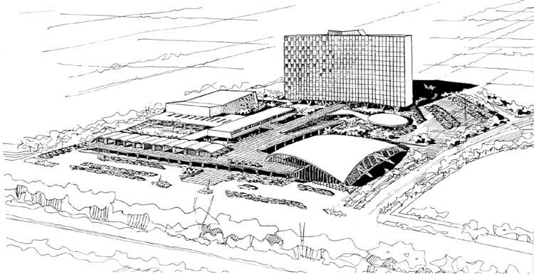

Bird´s eye perspective. “Todos” Shopping Center, 1956.

Copyright: Weberhofer File

<https://www.facebook.com/photo.php?fbid=156336507792047&set=a.156336491125382.35336.118946278197737&type=3&theater>

[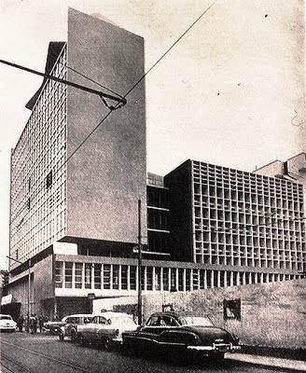](http://4.bp.blogspot.com/-p9hGTup7lSU/TbNBslq8qvI/AAAAAAAADsc/InyEmpJpGRk/s1600/EDIFICIO+ATLAS+arquitectos+Jos%C3%A9+%C3%81lvarez+Calder%C3%B3n+y+Walter+Weberhofer+pool+porta+guerrero+arquitectura+moderna.jpg)

Atlas Building, 1956.

Copyright: El Arquitecto Peruano Magazine.

[www.arquitectura-moderna-perú.blogspot.com](http://www.arquitectura-moderna-perú.blogspot.com)

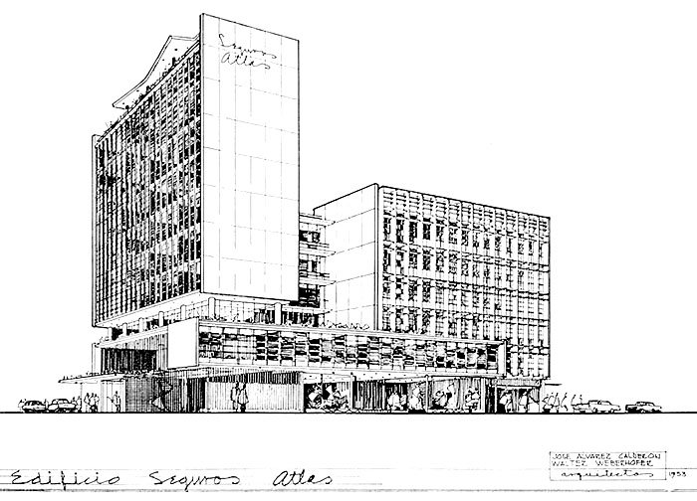

Atlas Building. Perspective. 1955.

Copyright: El Arquitecto Peruano Magazine

<https://www.facebook.com/photo.php?fbid=118950198197345&set=a.118950154864016.23653.118946278197737&type=3&theater>

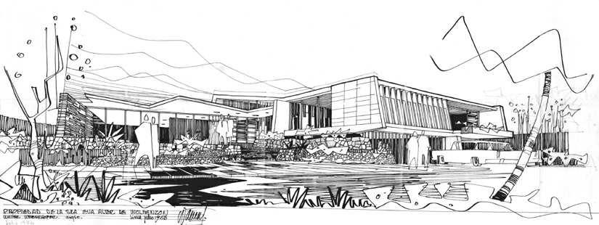

Alter Wolfenson House. Perspective. 1956.

Copyright: Weberhofer File

<https://www.facebook.com/photo.php?fbid=328398217252541&set=a.328398200585876.74456.118946278197737&type=3&theater>

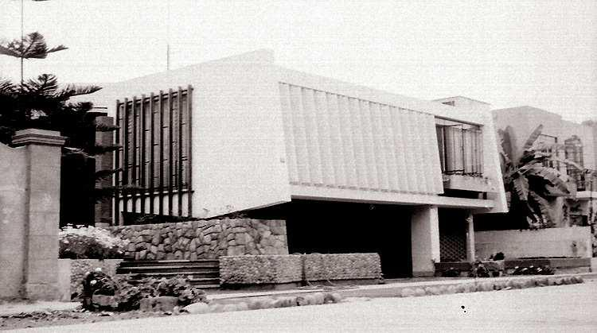

Alter Wolfenson House, 1956

Copyright: Weberhofer File

<https://www.facebook.com/photo.php?fbid=328398240585872&set=a.328398200585876.74456.118946278197737&type=3&theater>

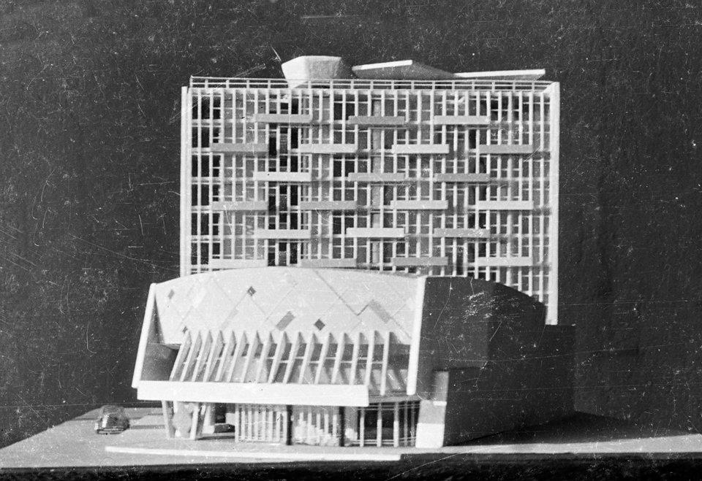

Tauro Cinema. Model, 1957.

Copyright: Weberhofer File.

<https://www.facebook.com/photo.php?fbid=254809407944756&set=a.254809124611451.58094.118946278197737&type=3&theater>

[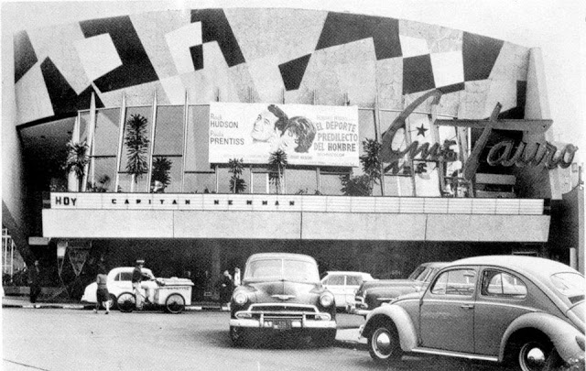](http://2.bp.blogspot.com/-rodpO-nw1Io/UPXxh-wGfPI/AAAAAAAAMTo/OQbE69_SJaw/s1600/3.jpg)

Tauro Cinema, 1957.

Copyright: Weberhofer File.

<http://laformamodernaenlatinoamerica.blogspot.com/2013/01/cine-tauro.html>

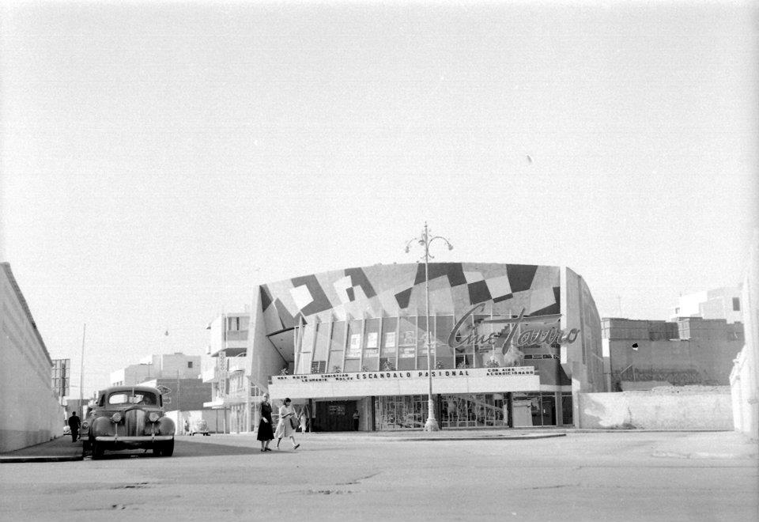

Tauro Cinema, 1959.

Copyright: Weberhofer File.

<https://www.facebook.com/photo.php?fbid=254666167959080&set=a.254666047959092.58076.118946278197737&type=3&theater>

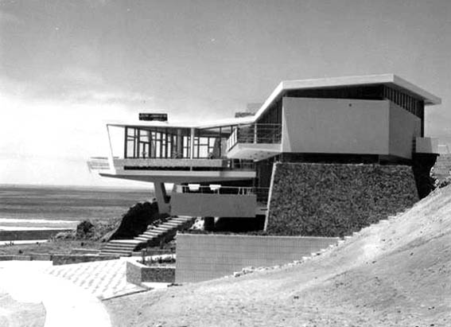

Lercari House, 1957.

Copyright: Weberhofer File.

<http://habitar-arq.blogspot.com/2011/08/el-archivo-weberhofer.html>

[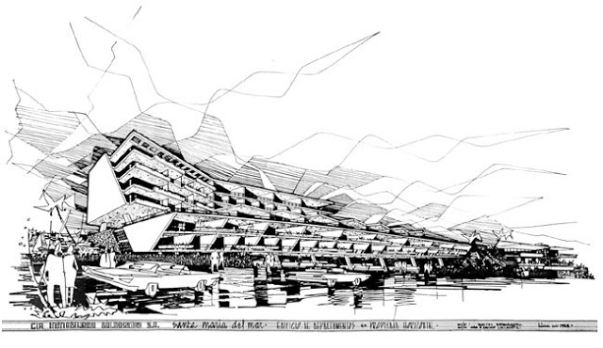](http://2.bp.blogspot.com/-edb6EGK-4jI/UPGrx9cjoLI/AAAAAAAAL3E/wECgIgwLzqU/s1600/527654_311952502230446_2147016489_n.jpg)

Las Sirenas Building. Perspective. 1957.

Copyright: Weberhofer File.

<http://laformamodernaenlatinoamerica.blogspot.com/2013/01/edificio-las-sirenas.html>

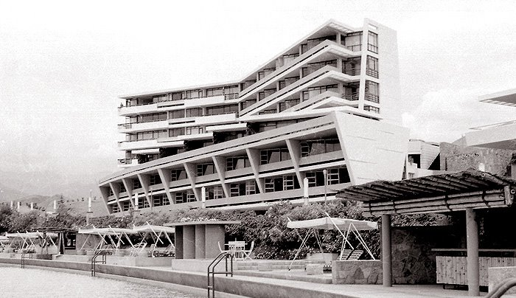

Las Sirenas Building (view form Esmeralda Yatch Club), 1959.

Copyright: Weberhofer File.

<https://www.facebook.com/photo.php?fbid=311951202230576&set=a.311950408897322.69759.118946278197737&type=3&theater>

[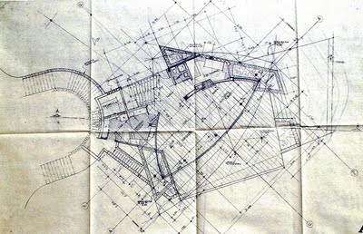](http://2.bp.blogspot.com/-miNoJh1oEGQ/TjXkVGyShoI/AAAAAAAAE9Q/Gl64gvoq97I/s1600/12-ac+1.jpg)

Alvarez Calderon House. Plan. 1958.

Copyright: Weberhofer File.

<http://habitar-arq.blogspot.com/2011/08/el-archivo-weberhofer.html>

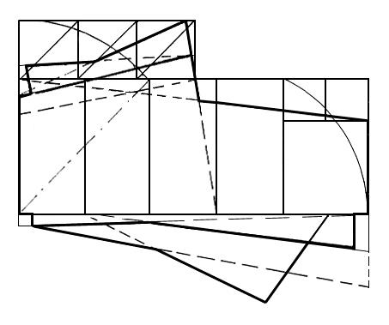

Esmeralda Yatch Club. Proportion study.

Copyright: Vicente Rojas (2001), *Influencia de la arquitectura brasileña en el Perú*.

<https://www.facebook.com/photo.php?fbid=312066422219054&set=a.312062018886161.69778.118946278197737&type=3&theater>

[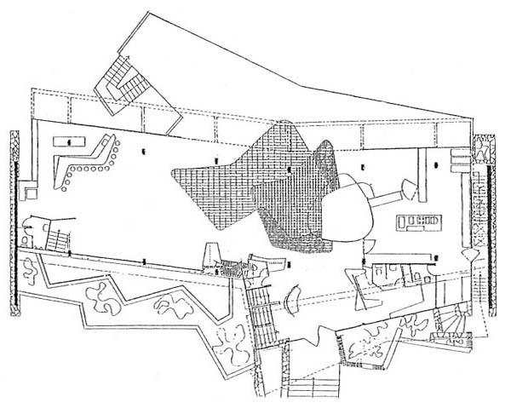](http://3.bp.blogspot.com/-WPUcMJu00FU/UPGm00JzTiI/AAAAAAAALzs/N5N3jjne7cE/s1600/270979_312066305552399_550840106_n.jpg)

Esmeralda Yacht Club. Plan. 1959.

Copyright: Weberhofer File.

Fuente: <http://laformamodernaenlatinoamerica.blogspot.com/2013/01/club-esmeralda.html>

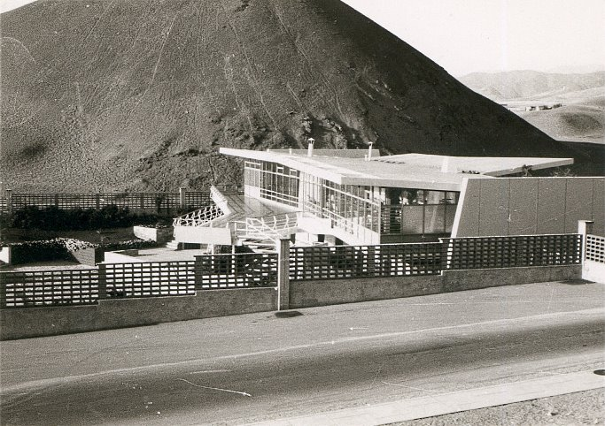

EsmeraldaYatch Club (view from Las Sirenas avenue), 1957.

Copyright: Weberhofer File.

<https://www.facebook.com/photo.php?fbid=312069315552098&set=a.312062018886161.69778.118946278197737&type=3&theater>

[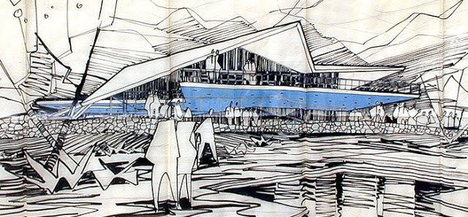](http://4.bp.blogspot.com/-4OS9OeOPt00/UPGX6mG9DUI/AAAAAAAALo4/6gGjcUOtEY0/s1600/423815_241221092636921_1529720226_n.jpg)

Pucusana Yacht Club. Perspective. 1961.

Copyright: Weberhofer File.

<http://laformamodernaenlatinoamerica.blogspot.com/2013/01/yacht-club-pucusana.html>

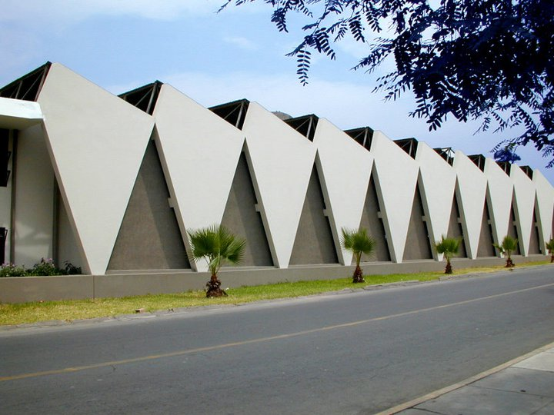

Mines Faculty, National University of Engineering, 1962-65 (with Remigio Collantes).

Copyright: Héctor Abarca

<https://www.facebook.com/photo.php?fbid=134508119974886&set=a.134507609974937.28664.118946278197737&type=3&theater>

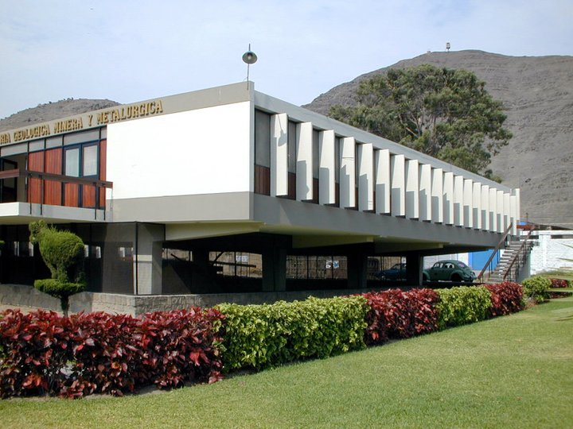

Mines Faculty, National University of Engineering, 1962-65 (with Remigio Collantes).

Copyright: Héctor Abarca

<https://www.facebook.com/photo.php?fbid=134507723308259&set=a.134507609974937.28664.118946278197737&type=3&theater>

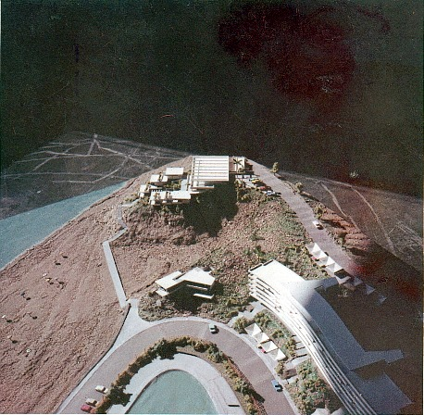

Projects in Santa María del Mar. Scale model.

Copyright: Weberhofer File.

<https://www.facebook.com/photo.php?fbid=495210563904638&set=pb.118946278197737.-2207520000.1377556893.&type=3&theater>

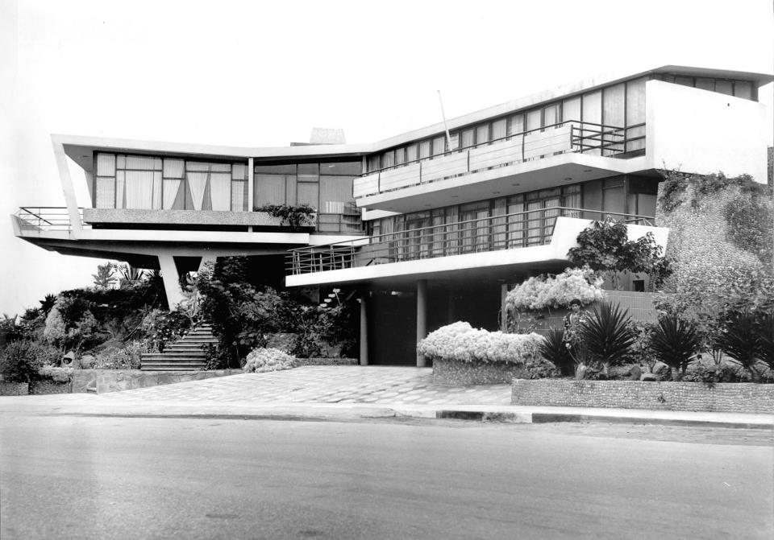

Lercari House, 1968.

Copyright: Weberhofer File.

<https://www.facebook.com/photo.php?fbid=147972138628484&set=a.147953425297022.32232.118946278197737&type=3&theater>

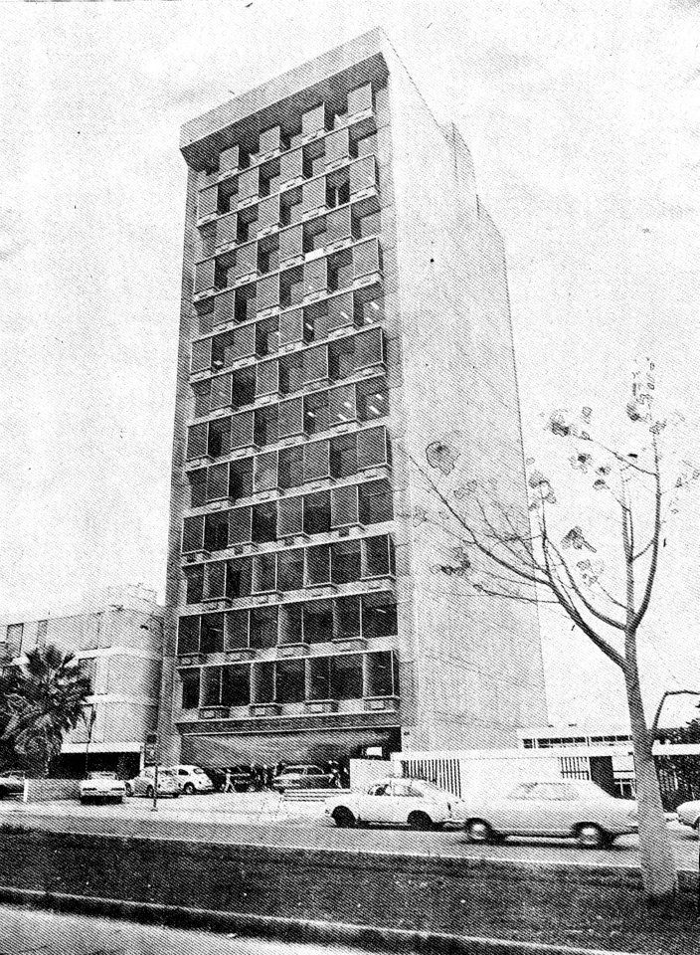

Otepsa Biulding, 1973-74.

Copyright: “Oiga” Magazine (may, 1977).

<https://www.facebook.com/photo.php?fbid=318097288282634&set=a.318095471616149.71007.118946278197737&type=3&theater>

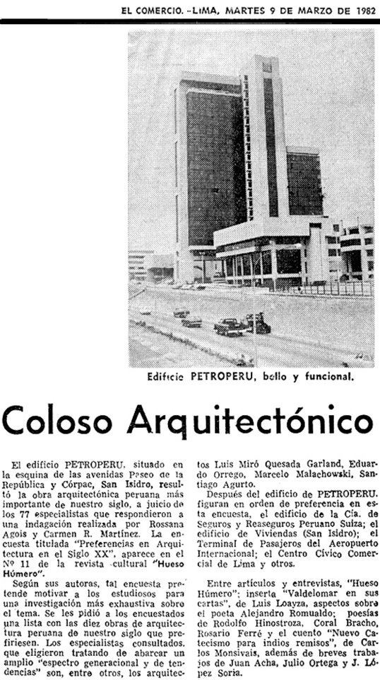

Petroperú, fotografía, 1973.

Copyright: El Comercio. Publicado el 9 de marzo de 1982.

Fuente: <https://www.facebook.com/Walter.Weberhofer.Arquitecto/iphotos_albums>

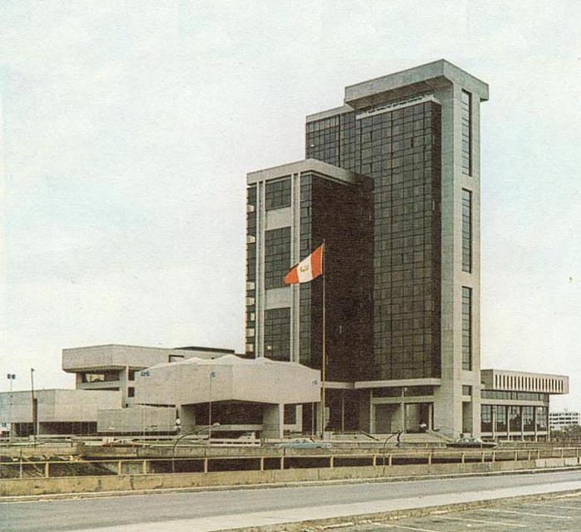

Petroperú (con Daniel Arana), 1970-1973.

Copyright: Revista “Arquitectura, Vivienda y Construcción” #1, 1974.

<https://www.facebook.com/photo.php?fbid=156975904394774&set=a.156972761061755.35528.118946278197737&type=3&theater>

1. Italian architect, who received the responsability for the design of the building that would house the FAUA UNI (1951), the first school of architecture in Peru, founded in 1910 and restructured in 1948 according to the modern approach.
2. “Theodore Cron was a swiss architect who studied in Zurich and completed his studies at the Hochschule Technnidsche Eidgenossische. In some of his work, one can infer, that he was influenced by Mies Van Der Rohe and Le Corbusier”.

   [“*Teodoro Cron es un arquitecto suizo que estudió en  Zúrich y terminó sus estudios en el Eidgenossische Technnidsche Hochschule. En algunas de sus obras se podría deducir que fue influenciado por Mies Van Der Rohe y Le Corbusier*”]

   <http://introarquitectura2012-01.blogspot.com/2012/06/teodoro-cron.html>
3. In 1953 Walter Gropius and Josep Luis Sert worked on the restructuration of the academic content of the FAUA, leaving the classical concept of architectural design.
4. <http://habitar-arq.blogspot.com/2011/12/edificio-atlas.html>
5. “Metabolism was the most important urban, architectural, artistic and philosophical movement produced in Japan in the twentieth century. Its influence went beyond the utopian concepts of a society that experienced rapid economic growth in the decade of the 60s and materialized in specific projects not only in Japan but also beyond its borders”.

   [“*El Metabolismo fue el movimiento urbano, arquitectónico, artístico y filosófico más importante que ha producido Japón en el siglo XX. Su influencia sobrepasó los conceptos utopistas de una sociedad que experimentó un vertiginoso crecimiento económico en la década de los 60s y se materializó en proyectos específicos no sólo en Japón sino más allá de sus fronteras*”].

   <http://moleskinearquitectonico.blogspot.com/2011/10/el-metabolismo-japones.html>
6. “*Weberhofer será recordado sobre todo por el trabajo como arquitecto exclusivo de Santa Maria del Mar, aunque sus dotes de proyectista siempre han sido reducidas por el medio que siempre ha buscado etiquetar al arquitecto dentro de alguna escuela internacional, un estilo, un maestro. Porque si no es de influencia brasileña, su trabajo esta bajo la sombra del metabolismo japonés* [], *o es evidente el aura de Richard Neutra y Paul Rudolph*”.
7. <http://laformamodernaenlatinoamerica.blogspot.com/2013/01/edificio-seguros-atlas.html>
8. <https://www.facebook.com/Walter.Weberhofer.Arquitecto>
9. <http://issuu.com/hector_abarca/docs/expo_2012>